**COMSATS UNIVERSITY ISLAMABAD**

**ATTOCK CAMPUS**



**NAME:** Abbas Khan | Ahsan Khan

**Reg. No:** SP22-BSE-020 | SP22-BSE-016

**SUBJECT:** Human Computer Interaction

**DATE:** 26th March, 2025

**Detailed PACT Analysis of the Car Showroom Management System**

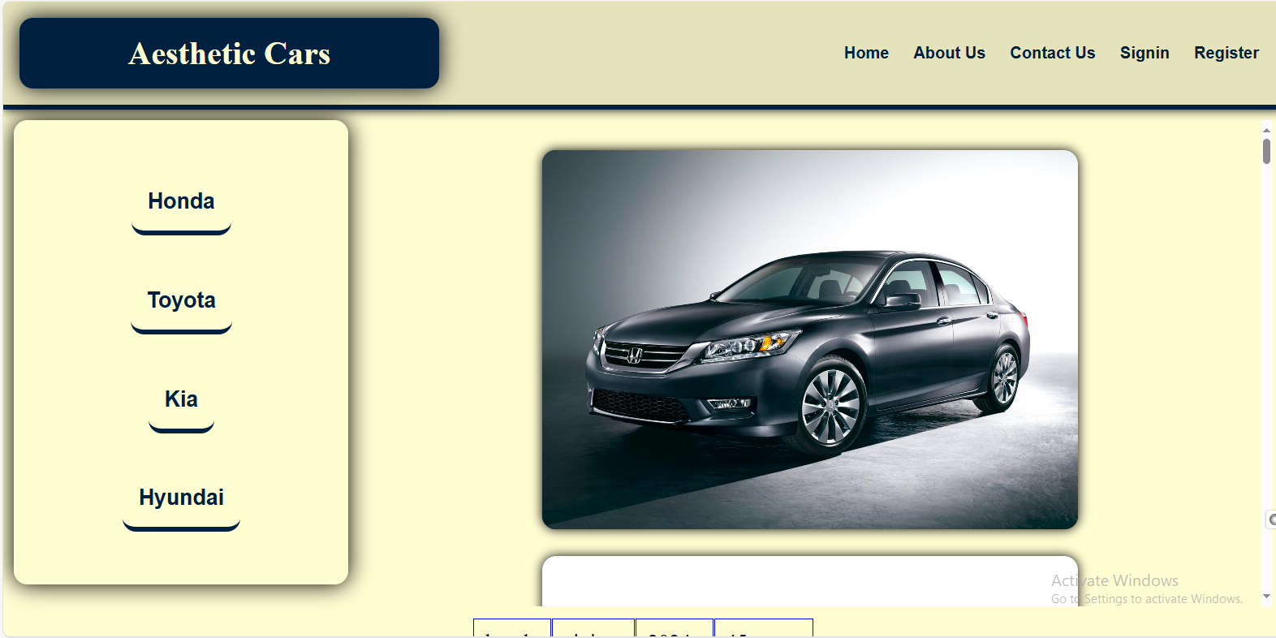

The **Car Showroom Management System** is a web-based platform designed for automobile sale and purchase agencies, enabling efficient inventory management and customer interaction. Below is an in-depth **PACT (People, Activities, Contexts, and Technologies) analysis** to evaluate the system from an HCI perspective.

1. **People**

This system has two primary types of users:

**a. Agency Employees (Showroom Staff)**

**- Roles:**

**-** Manage vehicle records (add, update, delete listings).

- Authenticate and access secured features.

- Maintain inventory integrity.

**- Skill Level:**

**-** Expected to have basic computer literacy.

- Familiar with showroom operations and inventory tracking.

**- Challenges:**

**-** Employees may need a user-friendly dashboard with intuitive navigation.

- Training might be required if the system has complex functionalities.

**b. Customers (Vehicle Buyers)**

**- Roles:**

**-** Browse available vehicles.

- View images, details, and specifications.

**- Skill Level:**

**-** Varies from tech-savvy individuals to less experienced users.

**- Challenges:**

**-** The interface should be easy to navigate for all types of users.

- Filtering/searching options would enhance the experience.

1. **Activities**

The system supports two sets of activities, categorized by user type.

**a. Activities for Agency Employees**

**- Login & Authentication:**

**-** Employees must securely log in to access management features.

**- Adding/Updating Vehicle Records:**

**-** Input vehicle details, including make, model, price, and images.

- Modify or remove outdated listings.

**- Managing User Access:**

**-** Ensure proper authentication and authorization.

- Maintain security and confidentiality.

**b. Activities for Customers**

**- Browsing & Viewing Vehicles:**

- Explore listed vehicles with images and descriptions.

**- Searching & Filtering (Planned Feature):**

**-** Customers may want to search based on brand, price range, model year, etc.

**- Making Purchase Decisions:**

**-** Although not explicitly mentioned, adding a contact or inquiry feature could improve engagement.

1. **Contexts**

The system operates in multiple contexts, affecting usability and design choices.

**a. Physical Context**

**- For Employees:**

- Likely used in offices or showroom environments.

- Requires stable internet connectivity and device compatibility (PCs, laptops).

**- For Customers:**

**-** Used in various locations (homes, cafes, mobile devices).

- Should support multiple screen sizes (desktop, mobile, tablet).

**b. Social Context**

**- For Employees:**

**-** Collaboration may be required among multiple staff members.

- Permissions and access control should be in place.

**- For Customers:**

**-** Independent browsing; customers should easily find relevant information.

**c. Technological Context**

**- Devices:**

**-** Desktop and mobile browsers should be supported.

**- Internet Requirements:**

**-** Needs consistent internet access for database interactions.

**- Security Considerations:**

**-** User authentication should prevent unauthorized modifications.

**-** HTTPS implementation for data security.

**The ‘context’ mentioned here is taken as an idea from the following website: {** [The PACT Analysis: A Human-Centered Design Framework – Bornoe.org blog](https://bornoe.org/blog/2023/04/the-pact-analysis-a-human-centered-design-framework/) **}**

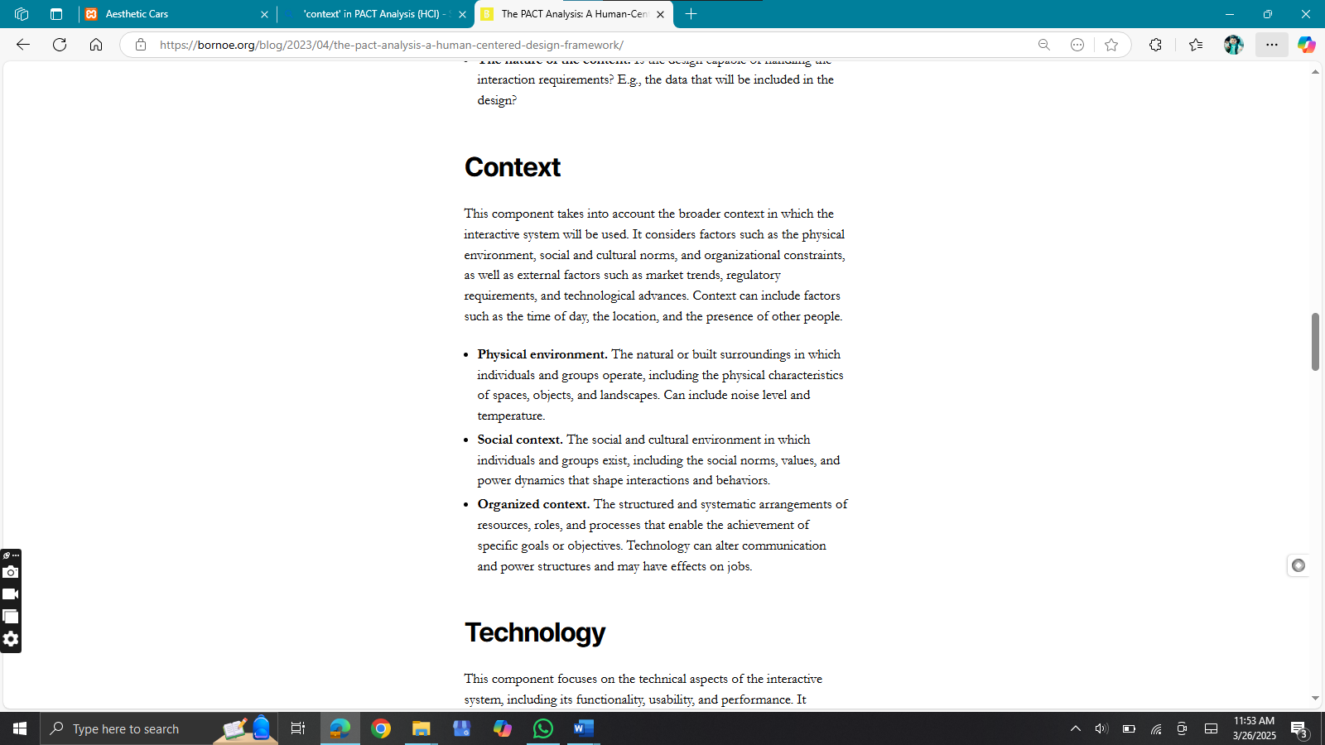

1. **Technologies**

The system is built using a combination of frontend and backend technologies.

**a. Frontend (Client-Side)**

**- HTML & CSS for designing the website.**

**- Future Enhancements:**

- Implement JavaScript for dynamic interactions.

- Responsive design for mobile compatibility.

**b. Backend (Server-Side)**

**-** PHP for handling business logic and authentication.

**- Future Enhancements:**

**-** Integration with MySQL or another database for better data management.

**-** Implement AJAX to load data dynamically without refreshing the page.

**c. Security Considerations**

**- Current Setup:**

**-** Basic authentication system using PHP.

**- Recommended Enhancements:**

**-** Encrypted passwords (e.g., *bcrypt* or *hashing functions*).

- Role-based access control for different types of employees.